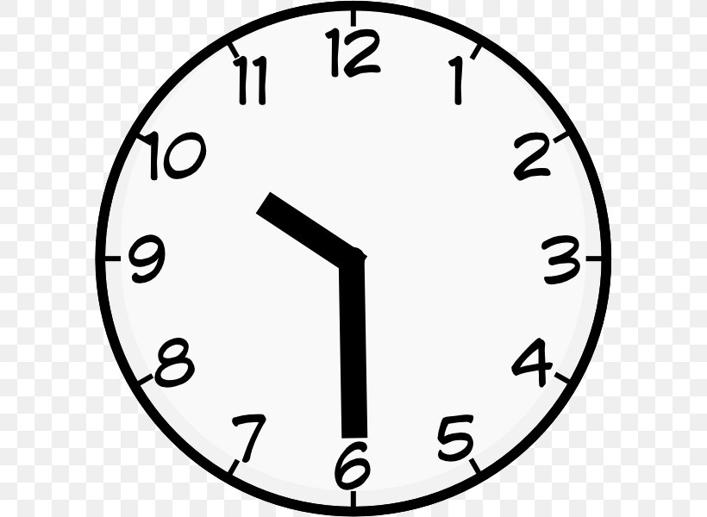
Learning English: The Time

A: What's the time?
B: It’s ten thirty.

Here are some more examples:
12:00 It's twelve o'clock. / It's twelve. / It’s midday / It’s noon. / It’s midnight.
1:15 It's one fifteen am
2:30 It's two thirty am
15:20 It's three twenty pm
6:45 It's six forty-five am
4:00 It's four in the morning. / It's four am
16:00 It's four in the afternoon. / It's four pm
20:00 It's eight o'clock at night. / It’s eight pm
6:10 It's six ten am
7:50 It's seven fifty am
17:55 It’s five fifty-five pm
(Note that we only use a 12-hour clock in English)

Exercise. What’s the time?
- 12:15 It’s _____________________________
- 3:30 It’s _____________________________
- 17:00 It’s _____________________________
- 8:47 It’s _____________________________
- 11:10 It’s _____________________________
- 22:30 It’s _____________________________
- 4:45 It’s _____________________________
- 1:30 It’s _____________________________
- 7:15 It’s _____________________________
- 3:35 It’s _____________________________

